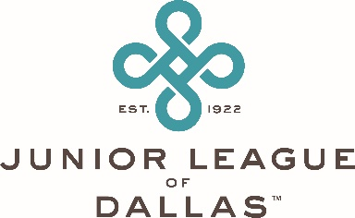
Memorial Directive
I, __________________________________________, in lieu of flowers at my funeral or memorial service, would like all memorials or remembrances in my name be for the benefit or use of:
Junior League of Dallas
8003 Inwood Road
Dallas, TX 75209-3335

Main Office: 214-357-8822
Email: development@jld.net

Contributions should be sent to the above organization with a note indicating such contribution is in my name and for the benefit of the above-mentioned nonprofit organization.

Copies of this form should be made available as follows:
_____ For those attending my funeral or memorial service
_____ Shared with my family members or friends
_____ Attached to my will and given to my heirs/beneficiaries
_____ Published in a local newsletter of general circulation as part of my obituary
_____ Other: __________________________________________________________

Contributions are tax deductible to the full extent of the law. The Junior League of Dallas is a 501(c)(3) nonprofit. If additional information is needed, please call JLD Headquarters at 214-357-8822.

_________________________________________ _______________
(signed) (date)

Junior League of Dallas Mission Statement
The Junior League of Dallas is an organization of women committed to promoting voluntarism, developing the potential of women and improving the community through the effective action and leadership of trained volunteers.

